URL: <http://www.edah-hospital.com/>

**E-Da Hospital** achieved Joint Commission International (JCI) Accreditation in November 2008 and is the first JCI accredited hospital in south Taiwan.

**Objective**To improve quality and pursue excellence  
  
**Vision**To be a first-rate international medical center for critical care  
***Core Value***Love and care, responsibility and sustainability

**Services:**

[Brachial Plexus Injury Treatment](http://www.edah-hospital.com/file/international/international-ms01.html)

[Intracranial Endoscopic Neurosurgery](http://www.edah-hospital.com/file/international/international-ms24.html)

[Cardiac Catheterization](http://www.edah-hospital.com/file/international/international-ms02.html)

[Examination with intervention](http://www.edah-hospital.com/file/international/international-ms02.html)

[Kidney Transplant](http://www.edah-hospital.com/file/international/international-ms11.html)

[Coronary Artery Bypass Graft (CABG)](http://www.edah-hospital.com/file/international/international-ms04.html)

[Laparoscopic Bariatric Surgery](http://www.edah-hospital.com/file/international/international-ms12.html)

[Laser Treatment](http://www.edah-hospital.com/file/international/international-ms14.html)

[Liver Transplant](http://www.edah-hospital.com/file/international/international-ms15.html)

[Lymphoedema Treatment](http://www.edah-hospital.com/file/international/international-ms16.html)

[Discectomy](http://www.edah-hospital.com/file/international/international-ms05.html)

[Esophageal & VoiceReconstruction](http://www.edah-hospital.com/file/international/international-ms06.html)

[Polysomnography](http://www.edah-hospital.com/file/international/international-ms17.html)

[Prostate Laser Surgery](http://www.edah-hospital.com/file/international/international-ms18.html)

[Pulsed Radiofrequency Lesioning](http://www.edah-hospital.com/file/international/international-ms25.html)

[Funnel Chest (Pectus excavatum)](http://www.edah-hospital.com/file/international/international-ms23.html)

[Gamma Knife Radiosurgery](http://www.edah-hospital.com/file/international/international-ms07.html)

[Total Knee and Total Hip[Replacement](http://www.edah-hospital.com/file/international/international-ms21.html)](http://www.edah-hospital.com/file/international/international-ms21.html)

[Hyperhidrosis Treatment](http://www.edah-hospital.com/file/international/international-ms09.html)

[Hysteroscopic Surgery](http://www.edah-hospital.com/file/international/international-ms10.html)

[Valve Replacement](http://www.edah-hospital.com/file/international/international-ms22.html)

**Doctor’s credentials**

**Doctors in cardiology**

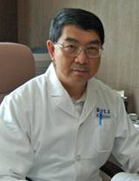 [Kwan-Lih Hsu, M.D.](http://www.edah-hospital.com/file/Doctor/drprofile/Cardiology/3-1-1a.htm)

Antecedent

§ Doctor, Clinical Medicine, National Taiwan University, Taiwan

§ Bachelor, Medicine, National Taiwan University, Taiwan

Experience

§ Assistant Professor, Medicine, National Taiwan University

§ Visiting Staff, Internal Medicine, National Taiwan University Hospital

§ Resident, Internal Medicine, National Taiwan University Hospital

Specialties

§ Cardiology

§ Cardiac catheterization

§ Cardiac intervention

§ Hypertension

Position

Chairman, Department of Internal Medicine, E-Da Hospital

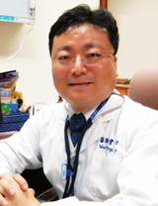 Wei-Kung Tseng, M.D.

Antecedent

§ MD, Chung-Shan Medical University

§ Master of Medical Affair Management, China Medical University

Experience

§ Intern, National Taiwan University Hospital, Taipei, Taiwan

§ Resident (Internal Medicine), National Taiwan University Hospital, Taipei, Taiwan

§ Fellow in Cardiology, National Taiwan University Hospital, Taipei,Taiwan

§ Attending VS in Cardiology, Cheng Ching Hospital,

§ Interventional cardiologist

§ Director of Coronary Care unit, Cheng Ching Hospital

§ Director of Case management Department, Cheng Ching Hospital

§ Director , Department of Cardiology, E-Da Hospital

Specialties

§ Cardiac and Vascular Ultrasound Examination

§ Preventive Cardiology (Hypertension, Dyslipidemia and Metabolic syndrome)

§ Familial Hypercholesterolemia genetic diagnosis and consultation

§ Congestive heart Failure Diagnosis and Management

§ Coronary Artery Disease Diagnosis and Management

Interventional Cardiology

§ Coronary artery stent and peripheral stent implantation

§ Rheumatic Heart disease and Valvular Heart Disease Diagnosis and Management

§ Peripheral vascular disease diagnosis and interventional therapy

§ Arrhythmia Diagnosis and Management; Pacemaker implantation

Position

Chief, Department of Cardiology, E-Da Hospital

**Doctor in cardio vascular**

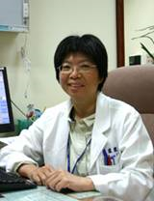 Lai-Fen Lu, M.D.

Antecedent

Kaohsiung Medical College (Medicine Degree)

Experience

§ Veterans General Hospital-Kaohsiung

  Ø 1991-1995: Residency

  Ø 1995-1996: Chief Residency

  Ø 1996-2004: Visiting Staff

§ E-DA Hospital

  Ø 2004-2005: Visiting Staff

  Ø 2005-: Chief of Division

Specialties

§ Acquired heart disease(coronary artery bypass grafting, vavular heart disease)

§ Great vessel disease

§ Peripheral arterial occlusive disease

§ Varicose vein

§ Vascular access

Position

Chief, Department of Cardiovascular Surgery, E-DA Hospital

**Doctors in orthopedics**

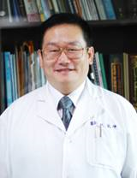 Yuan-Kun Tu, M.D.

Antecedent

Taipei Medical College

Experience

§ Ex-Chairman, Department of Orthopedics, E-Da Hospital

§ Director of Orthopedic Trauma, Chang Gung memorial hospital

§ Associate Professor, Chang Gung University

Specialties

§ Microsurgery hand surgery

§ Pediatric orthopedics

§ Bone tumors

§ Joint reconstruction

§ Brachical plexus reconstruction

Position

Vice Superintendent for Medicine, E-Da Hospital

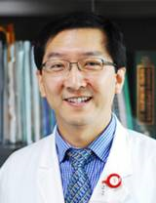 Shang-Won Yu, M.D.

Antecedent

National Defense Medical Center, Taipei, Taiwan

Experience

§ Chief Resident, Department of Orthopedic Surgery, Veterans General Hospital, Taipei

§ Attending Doctor, Division of Trauma Orthopedic, Orthopedic Department. Chang Gung Memorial Hospital

Specialties

§ Spine surgery

§ Joint reconstruction

§ Traumatology

Position

Chairman, Department of Orthopedics, E-Da Hospital

**Doctors in plastic surgery**

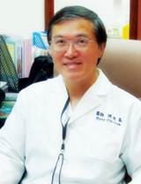 Hung-Chi Chen, M. D.

Antecedent

M.D., College of Medicine, National Taiwan University

Experience

§ Director of the Plastic Surgical Association of the Republic of China

§ Chief of the Section of Plastic Surgery of Chang Gung Hospital in Linkou

§ Research fellow of microsurgery at the Louisville Hand and Microsurgery Center, Kentucky, USA

§ Research fellow of microsurgery at the U. of Melbourne, Australia

§ Member of the American College of Surgeons (FACS)

Specialties

§ Reconstruction of the cervical esophagus and voice following total pharyngo-laryngectomy

§ Reconstruction after the resection of the head and neck cancers

§ Reconstruction of the extremities

§ Microsurgery of the intestinal transplantation

Position

§ Superintendent of E-Da Hospital

§ Professor of I-Shou University

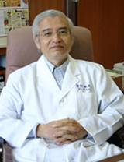 Yi-Tien Liu, M.D.

Antecedent

§ Master of Science, National Taiwan University, Taiwan

§ M.D. Taipei Medical College, Taiwan

Experience

§ Attending of Plastic Surgery in Chang Gung Hospital, Kaohsiung, Taiwan

§ Attending of Plastic Surgery in Chang Gung Hospital, Taoyuan, Taiwan

§ Visiting Scientist, Brigham & Women’s Hospital, Boston

Specialties

§ Head-Neck Surgery and Reconstruction

§ Craniofacial Surgery

§ Hand Surgery

§ General Plastic Surgery

Position

Chief, Department of Plastic Surgery, E-Da Hospital

**Doctor in general surgery**

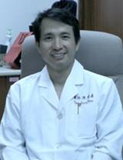 Yaw-Sen Chen, M.D.

Antecedent

Medical college of Chung Shang Medical University

Experience

§ Liver Transplantation Fellow of University of Pittsburgh U.S.A.

  Ø April 1992 - Oct. 1992

§ Chief, Division of General Surgery, Chang Gung Memorial Hospital, Kaohsiung Medical Center

  Ø July 2001 –June 2004

§ Deputy Chief, Department of Surgery, E-Da Hospital

  Ø February 2006- December 2007

§ Chief, Department of Surgery, E-Da Hospital

  Ø January 2008- till now

Specialties

§ Hepatobiliary and pancreas surgery

§ Liver transplantation

§ Gastro-intestine surgery

§ Endocrine surgery

Position

Chairman, Department of Surgery, E-Da Hospital

**Doctor in thoracic surgery**

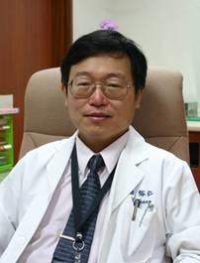 Yu-Jen Cheng, M.D.

Antecedent

Department of Medicine, Kaohsiung Medical University

Experience

§ Kaohsiung Medical University Hospital

§ Pittsburgh University Hospital

Specialties

§ Lung Cancer

§ Esophageal Cancer

§ Thoracoscopic Surgery

§ Chest wall deformity

Position

Chief, Department of Thoracic Surgery, E-Da Hospital

**Doctor in neurology**

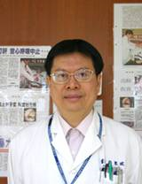 Shih-Pin Hsu, M.D.

Antecedent

Bachelor of Medicine, Taipei Medical University

Experience

§ Clinical Fellow and Attending Physician of Neurology, Kaohsiung Chang-Gung Memorial Hospital

§ Chief of Neurology, Chiayi Chang-Gung Memorial Hospital

§ Research Fellow of Clinical Electrophysiology of Department of Neurology, University of Iowa School of Medicine, Iowa, USA

§ Winner of 1993 International Scholarship Award of American Academy of Neurology

§ Board of Taiwan Society of Clinical Neurophysiology

§ Inclusion in 1994 Who’s who in the World®

Specialties

§ Sleep disorders

§ Epilepsy and Epilepsy Surgery

|  |
| --- |
|  |

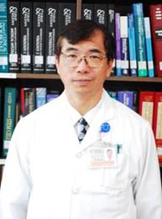 Han-Jung Chen, M.D.

Antecedent

§ National Taiwan University, School of Medicine, Taipei

§ Department of Neurosurgery, National Gunma University, Japan. Degree: Ph.D.

§ Division of Neurosurgery, Department of Surgery, Duke University Medical Center, U.S.A.

§ Institute of Health care management, National Sun Yet-sen University, Koshiung, Taiwan, Degree: MBA

Experience

§ Vice Superintendent, I-Shou University Hospital (E-Da Hospital)

§ Professor, I-Shou University

§ Attending Doctor and Director, Division of Neurosurgery, Chang Gung Memorial Hospital, Kaohsiung

§ Neurosurgical Fellow, Chang Gung Memorial Hospital, Linkou

§ Neurosurgical Resident and Chief Resident, National Taiwan University Hospital

§ Department of Surgery, Resident, National Taiwan University Hospital

Specialties

§ Electroneurophysiology

§ Pain Pathology

§ Neural regeneration

§ Neuro-oncology

Position

Vice Superintendent for Education, E-Da Hospital

**Contact us:**

Add: 1 yi-da road,

jiau shu tsuen,

yan-chau shiang kaoshiung

Taiwan

Email: [ed103221@edah.org.tw](mailto:ed103221@edah.org.tw).

Phone number: 886-7-6150011